
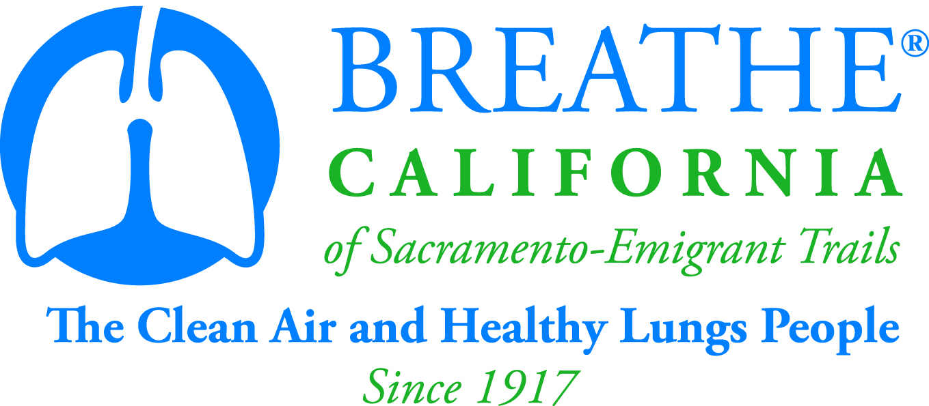

O24u Program FAQs

What Is the O24u Program?

The O24u program is an environmental education program provided to children in existing after school programs. Curriculum topics range from air pollution and health effect concepts to practical solutions that everyone can take to reduce harmful emissions of air pollution and toxic indoor environments. Each topic includes fun, hands-on, interactive activities that educate and empower children to make changes for clean air. The O24u curriculum provides the knowledge and background for the students to become advocates for clean air within their homes, schools and communities.

The program is a partnership with schools and after school service providers for a strong educational component that focuses on protection, restoration and conservation with primary focus on air, water and urban green space issues. Breathe California of Sacramento-Emigrant Trails (BREATHE) will train and afterschool program site facilitators to deliver the O24u program to children, ages 8-14.

The O24u curriculum has been developed to align with California Environmental Education Initiative principles. The O24u Facilitators Guide includes over 30 hands-on activities, along six topic areas. The Facilitators Guide corresponds directly to the student Activity Book, which every participating child will receive.

Who Funds O24u?

Funding for this program is made possible by a grant provided by the Rivercats Foundation, the Sacramento Metropolitan Air Quality Management District, Mr. & Mrs. G. Kirk Swingle Foundation, and the Yolo-Solano Air Quality Management District.

What Does the Funding Cover?

Funding covers program curriculum, student activity books, supplemental materials, training and support.

Who is BREATHE CA?

Breathe California of Sacramento-Emigrant Trails is dedicated to fighting for clean air, healthy lungs and a tobacco-free future. Originally founded in 1917, BREATHE is an independent non-profit working to make the Sacramento region and its surrounding communities a healthier place to live and breathe. For more information, call (916) 444-5900, or visit www.sacbreathe.org.

How can I get my Afterschool Program Involved?

Contact Natalie Lanning, Youth Programs Manager, at 916-444-5900 ext. 213 or nlanning@sacbreathe.org. Funding is limited to a few sites in Yolo, Solano, and Sacramento Counties.

